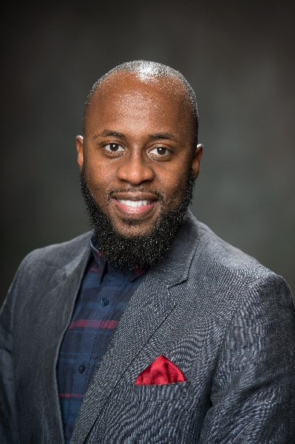
William A. Jefferson, M.P.A is the Administrative Community Manager for the Peace and Justice Institute at Valencia College. Influenced by his diverse background in both the public and non-profit sectors as an investigative analyst, financial examiner, behavioral health case manager and grant writer, he is determined to serve and protect disadvantaged and at-risk populations within the communities he lives and works.
A native of West Palm Beach, Florida, William A. Jefferson, M.P.A earned his Bachelors of Science in Criminal Justice from Bethune-Cookman University and a Master’s Degree in Public Administration from the University of Central Florida. He has experience in strategic planning, community outreach, financial auditing, fundraising development and public speaking. He has worked for the Office of Attorney General for the State of Florida, Office of Financial Regulations and has helped promote the advancement of education and adulthood success with Children’s Home Society of Florida. William sits on the Federal Bureau of Investigations (FBI) Board of Diversity and Inclusion for Central Florida and serves on Orange County Mayor Jerry Demings MLK Initiative. William believes that the work of Peace and Justice can be achieved one life, experience and conversation at a time.

